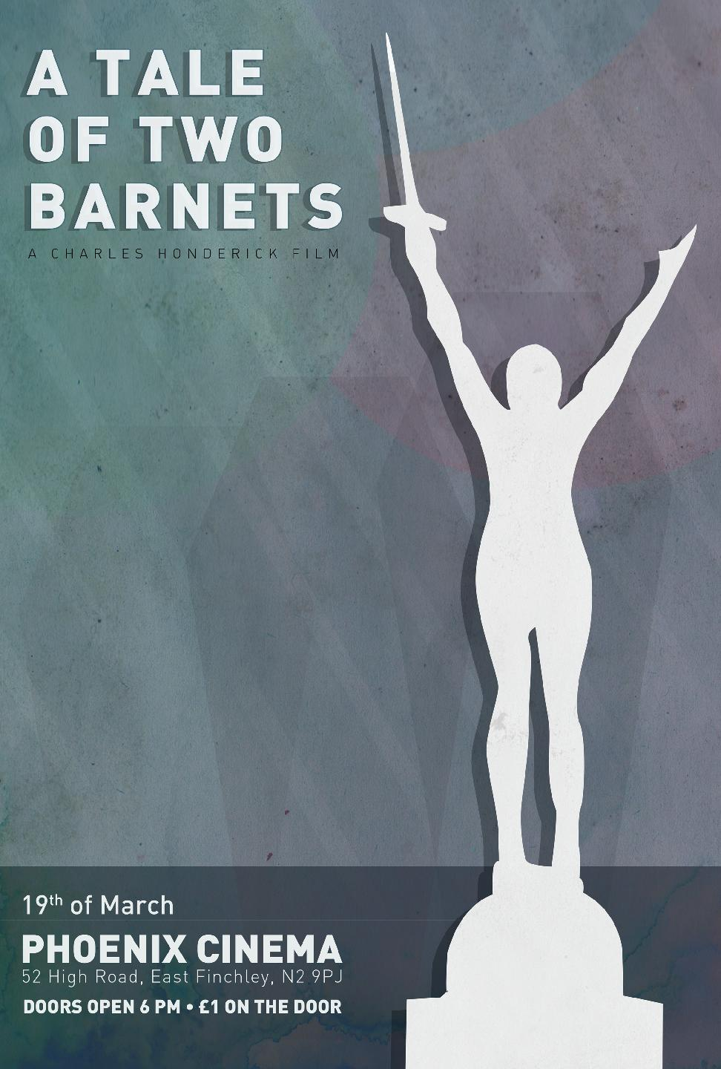 | Press Release : 20th March 2012  Successful Premiere for  A Tale of Two Barnets  Last night saw the gala Premiere of the Charles Honderick film “A Tale of Two Barnets” at the Iconic Phoenix Cinema in East Finchley. There was standing room only for the film, packing out the 250 seat venue. So many people turned up that a second screening was hurriedly arranged for latecomers who couldn’t watch the first sitting.  At the end of the first screening a short question and answer session with the public of Barnet was held. Members of the public expressed their views on many issues of local concern. George Jones from the Mill Hill Action group, stated that the group had collected 7,000 signatures, yet the council hadn’t listened to their views. He asked what members of the public had to do to make the council listen to local people.
Helen Michael, who was on the panel and appeared in the film, representing the views of local traders replied that they had collected 12,000 signatures against the parking policies and the Council hadn’t listened to them either. Disabled Barnet resident Phillip Rackham also stated that the council were ignoring the concerns of disabled people. David Attfield, from the Barnet CPZ campaign spoke of his concerns at plans by the council to hire out parks, and the disruption this will cause to ordinary residents who use the park on a daily basis for exercise and relaxation. One resident said “I came to see the film because I thought it was about the history of Barnet, I’m so glad I came and heard the stories of the people in the film”.
Several other local campaign groups attended the Premiere and asked if they could stage screenings of the film. These are currently being arranged. The Edgware Times covered the Premiere, with an excellent review of the evenings entertainment - http://www.times-series.co.uk/news/9599911.Barnet_Council_leader__sets_expectations_low__for_Barnet/
Many local people praised the idea of a local community film and expressed their thanks to the organisers for staging an affordable and entertaining evening. Director Charles Honderick said about the evening “I always had faith in the idea that people care about their community. I wanted to give a voice to the people of Barnet and the fantastic turnout tonight and response to the film shows that people want to listen”.

Further screenings have been arranged, with more to follow (please check website) - http://ataleoftwobarnets.yolasite.com/
Tuesday 27th March - 7-9 pm,
St. John's Church, Somerset / Mowbray Roads,
New Barnet,
EN5 1R

Wednesday 28 March - 7 pm
Greek Cypriot Community Centre
2 Britannia Road,
North Finchley,
London,
N12 9RU ‎

Tuesday 3rd April - 7:30 pm
Larches House,
1 Rectory Lane,
Edgware,
Middlesex,
HA8 7LF

Wednesday 18th April from 7pm
The Wilson Room
The House of Commons
London,
SW1A 2TT

A Tale of Two Barnets features local people in Barnet talking about their lives.
Some of the people who appeared in the film gave their views on the experience, why they appeared and what they hoped the film would achieve. Here’s what they had to say:
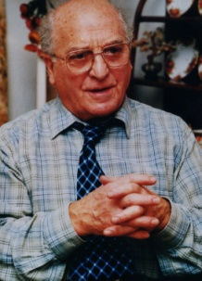 | Stan Davison, war veteran, member of Barnet 55+ forum.  The film's title "A Tale of Two Barnets" has a good local touch, yet relates to the national scene, the message is clear, 'broad campaigning in unity' is the message. As a war veteran, trade unionist and campaigning pensioner in the community that suits me fine. We are in a people's fight. I am glad to be part of this action.
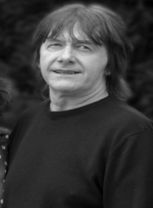 | Bernard Cochrane – Operator Bushey Mill Care facility  I got involved to express my concerns and raise awareness of issues.  I specifically wanted to make people aware of the issue of The London Borough of Barents 'independent' LATC [Local Authority Trading Company] and how it affects independent care providers.
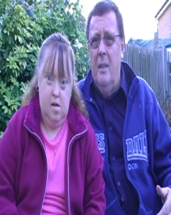 | John Sullivan – Parent Carer  I wanted to appear in this film because the voice of those with a disability and the elderly are not being heard. I hope this film exposes to the general public the misinformation being distributed by Barnet councillors, wherein they are saying that everything in the garden is rosy and everybody has been meaningfully consulted on the privatisation of support services when that is simply untrue.
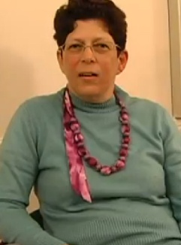 | Tirza Waisel-Cohen – Social Worker  Old, disabled and ill people are the ones who are most voiceless simply because they are burdened by their particular vulnerability. They have so many problems and issues to take care of at a time when they most lack energy and confidence precisely because of their illness, frailty or disability - and the fact they are the ones picked on is an injustice that screams volumes and must be urgently rectified. That's completely besides the fact that any of us who are lucky to be able bodied and healthy can become vulnerable in that way any day. Not the point - but worth remembering and reminding ourselves….
Award Winning director, Ken Loach has given the film his full backing. He says “In the film you will hear some of the stories about the privations people are undergoing. It’s particularly savage if you are disabled, if you don't have much money, if you are old, and if you are young.” - See Ken Loach talk about "A Tale of Two Barnets" in an exclusive interview.
The film has made the front page of the Barnet Press, a leading local paper in the London Borough of Barnet
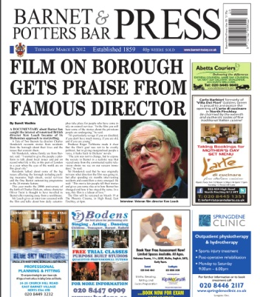
http://edition.pagesuite-professional.co.uk/launch.aspx?referral=other&refresh=Jo5106Kn2k1S&PBID=f8297918-4e99-4dfb-9199-5ba5cfd6d926&skip=
Official Film Website : http://ataleoftwobarnets.yolasite.com/

About Director Charles Honderick
“My name is Charles Honderick, filmmaker, producer, musician, man about town. I was born and raised in Florida. I have been involved in film production for several years, making short films and music videos. I was looking for a new project and an opportunity arose to make a film about the people of Barnet, a suburb on the edge of London, in the year of the Olympics 2012”.

Press Contacts : Roger Tichborne – 07754 910425 – Email : Roger.Tichborne@btinternet.com
***** The Premiere of A Tale of Two Barnets is being supported by Barnet Trades Council *****
Notes for Editors :
- The film “A Tale of Two Barnets” is 28 minutes long
- Charles Honderick is available for interview upon request
- The film has been produced by The Mill Hill recording Company Ltd – part of Mill Hill Music Complex
- Please direct all press enquiries via Roger Tichborne
- The film is currently being entered into several competitions for documentary films
- On march 19th between 6pm & 6.40pm, members of the press will be able to speak to people who appeared in the film, for interviews and photos.
- Following the film, a panel including Charles Honderick will answer questions for approx 25 minutes.
- DVD copies of the film will be available
- Further Youtube trailers will be placed on the website at http://ataleoftwobarnets.yolasite.com/gallery-and-trailers.php
- Quotes from the Ken Loach interview
“In all the towns and cities in this country there are daily catastrophes taking place for disabled people , old people and young people who have come to rely on the services of the council.”

“We find not only are they being cut back they are being hived off to private companies who are now going to make a profit out of what we used to see as a service ..this is not acceptable, and together we have to fight it in the coming film you will hear some of their stories...”

“It is particularly savage if you are disabled, if you don’t have much money, if you are old, and you are young..”

“These councils are pursuing hard right policies, privatisation, cutting back or destroying local the local community through cuts in local services.”

“Remember the welfare state which established after the second world war where the basis was we were stronger as a team than we were as individuals, we need to remember that again”
“Enjoy the film, good luck to the campaign, and let’s make it count!”
Please contact via email for further quotes etc

