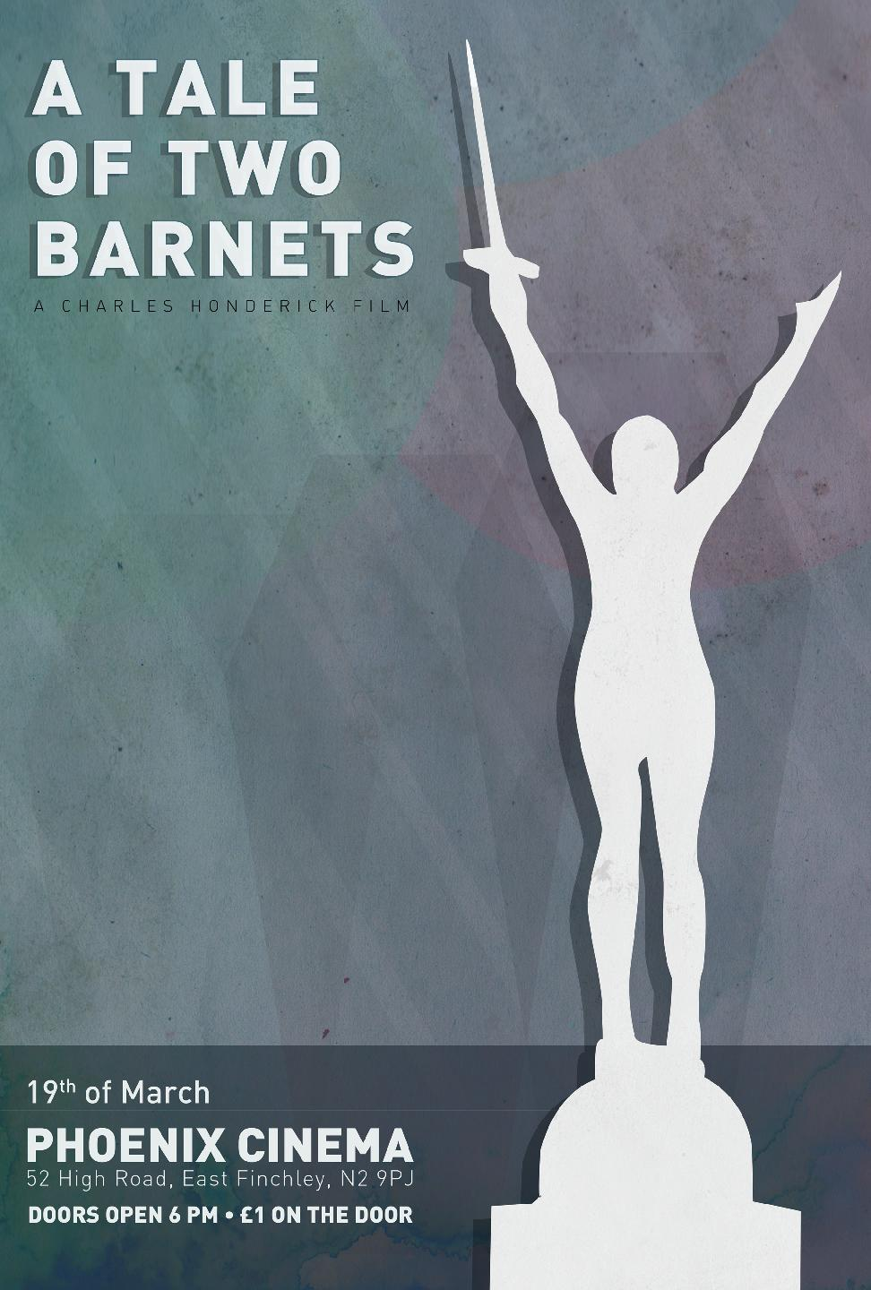 | Press Release : 29th February 2012  A Tale of Two Barnets  World Premiere  Monday 19th March - 6-8pm  The Phoenix Cinema,  52 High Road,  East Finchley,  London  N2 9PJ  A documentary film about people in a London suburb in the year 2012. Barnet, site of the famous workhouse from the story Oliver Twist. Two hundred years after the birth of Charles Dickens, how has the area changed and how has it stayed the same? The people of Barnet talk about their lives and their concerns in 2012.  According to film maker Charles Honderick, “My mother's family are from the London Borough of Barnet and I'd spent a lot of time growing up there, so in a way this film was a labour of love. I wasn't quite sure what direction the film was going to take when it began, but as I interviewed people a story emerged. I wanted to give the people of Barnet a platform to talk about important local issues and put on record what life is like in this part of London in a year when the eyes of the world are on the great city of London.”
Charles Honderick spent six months interviewing residents of a sleepy London borough, talking about their lives and the issues that concern them. He has produced a powerful film which illustrates the lives and challenges facing the people of Barnet . Council leaders talk about their policies and local people talk about the effect these policies have on them. The role of the High Street in the community is examined and how people at the cutting edge of these times of economic austerity are coping . The film gives a voice to those people who are normally brushed aside into the margins of society.
About Charles Honderick
“My name is Charles Honderick, filmmaker, producer, musician, man about town. I was born and raised in Florida. I have been involved in film production for several years, making short films and music videos. I was looking for a new project and an opportunity arose to make a film about the people of Barnet, a suburb on the edge of London, in the year of the Olympics 2012”.
What people are saying about "A Tale of Two Barnets"
Ken Loach- Film Director –  In the film you will hear some of the stories about the privations people are undergoing. It's particularly savage if you are disabled or you are old. See Ken Loach talk about "A Tale of Two Barnets" in an exclusive interview. |  |  | Kate Belgrave - Journalist –  The interviews are the great part of it - really impressive

Official Website : http://ataleoftwobarnets.yolasite.com/
Press Contacts : Roger Tichborne – 07754 910425 – Email : Roger.Tichborne@btinternet.com
***** The Premiere of A Tale of Two Barnets is being supported by Barnet Trades Council *****
Notes for Editors :
- The film “A Tale of Two Barnets” is 28 minutes long
- Charles Honderick is available for interview upon request
- The film has been produced by The Mill Hill recording Company Ltd – part of Mill Hill Music Complex
- Please direct all press enquiries via Roger Tichborne
- The film is currently being entered into several competitions for documentary films
- On march 19th between 6pm & 6.40pm, members of the press will be able to speak to people who appeared in the film, for interviews and photos.
- Following the film, a panel including Charles Honderick will answer questions for approx 25 minutes.
- DVD copies of the film will be available
- Further Youtube trailers will be placed on the website at http://ataleoftwobarnets.yolasite.com/gallery-and-trailers.php
- Quotes from the Ken Loach interview
“In all the towns and cities in this country there are daily catastrophes taking place for disabled people , old people and young people who have come to rely on the services of the council.”

“We find not only are they being cut back they are being hived off to private companies who are now going to make a profit out of what we used to see as a service ..this is not acceptable, and together we have to fight it in the coming film you will hear some of their stories...”

“It is particularly savage if you are disabled, if you don’t have much money, if you are old, and you are young..”

“These councils are pursuing hard right policies, privatisation, cutting back or destroying local the local community through cuts in local services.”

“Remember the welfare state which established after the second world war where the basis was we were stronger as a team than we were as individuals, we need to remember that again”

“Enjoy the film, good luck to the campaign, and let’s make it count!”
Please contact via email for further quotes etc

