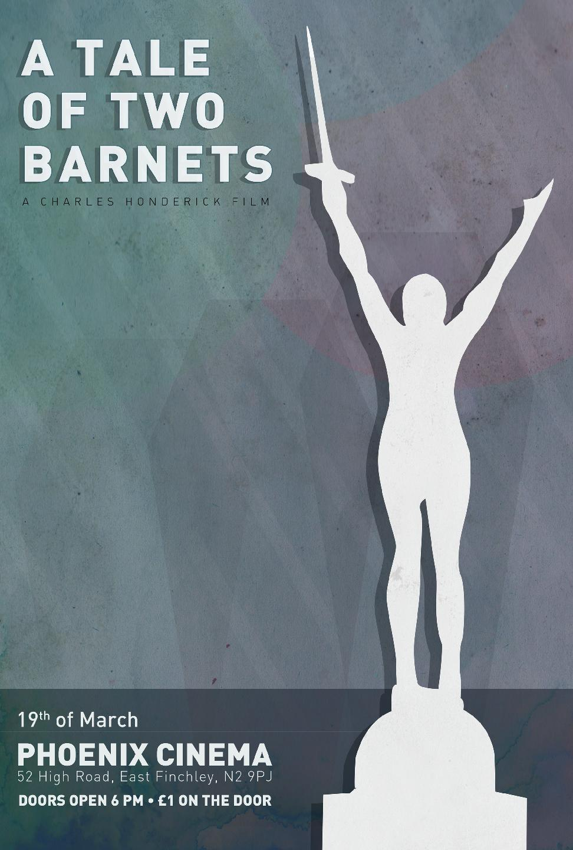 | Press Release : 8th March 2012  Award winning director Ken Loach backs film about Barnet  A Tale of Two Barnets  World Premiere  Monday 19th March - 6-8pm  The Phoenix Cinema,  52 High Road,  East Finchley,  London  N2 9PJ  A DOCUMENTARY about the way people in Barnet are coping with life in 2012 has caught the interest of renowned British director Ken Loach. Mr Loach gives an interview screened with the film and talks about how daily catastrophes take place for people who have come to rely on council services. In the interview he says
“In the film you will hear some of the stories about the privations people are undergoing. It’s particularly savage if you are disabled, if you don't have much money, if you are old, and if you are young.” - See Ken Loach talk about "A Tale of Two Barnets" in an exclusive interview.
The film has made the front page of the Barnet Press, a leading local paper in the London Borough of Barnet
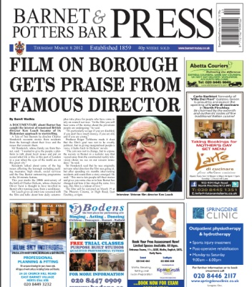
http://edition.pagesuite-professional.co.uk/launch.aspx?referral=other&refresh=Jo5106Kn2k1S&PBID=f8297918-4e99-4dfb-9199-5ba5cfd6d926&skip=
Official Film Website : http://ataleoftwobarnets.yolasite.com/

About Director Charles Honderick
“My name is Charles Honderick, filmmaker, producer, musician, man about town. I was born and raised in Florida. I have been involved in film production for several years, making short films and music videos. I was looking for a new project and an opportunity arose to make a film about the people of Barnet, a suburb on the edge of London, in the year of the Olympics 2012”.

Press Contacts : Roger Tichborne – 07754 910425 – Email : Roger.Tichborne@btinternet.com
***** The Premiere of A Tale of Two Barnets is being supported by Barnet Trades Council *****
Notes for Editors :
- The film “A Tale of Two Barnets” is 28 minutes long
- Charles Honderick is available for interview upon request
- The film has been produced by The Mill Hill recording Company Ltd – part of Mill Hill Music Complex
- Please direct all press enquiries via Roger Tichborne
- The film is currently being entered into several competitions for documentary films
- On march 19th between 6pm & 6.40pm, members of the press will be able to speak to people who appeared in the film, for interviews and photos.
- Following the film, a panel including Charles Honderick will answer questions for approx 25 minutes.
- DVD copies of the film will be available
- Further Youtube trailers will be placed on the website at http://ataleoftwobarnets.yolasite.com/gallery-and-trailers.php
- Quotes from the Ken Loach interview
“In all the towns and cities in this country there are daily catastrophes taking place for disabled people , old people and young people who have come to rely on the services of the council.”

“We find not only are they being cut back they are being hived off to private companies who are now going to make a profit out of what we used to see as a service ..this is not acceptable, and together we have to fight it in the coming film you will hear some of their stories...”

“It is particularly savage if you are disabled, if you don’t have much money, if you are old, and you are young..”

“These councils are pursuing hard right policies, privatisation, cutting back or destroying local the local community through cuts in local services.”

“Remember the welfare state which established after the second world war where the basis was we were stronger as a team than we were as individuals, we need to remember that again”
“Enjoy the film, good luck to the campaign, and let’s make it count!”
Please contact via email for further quotes etc

